SITE PHOTOS

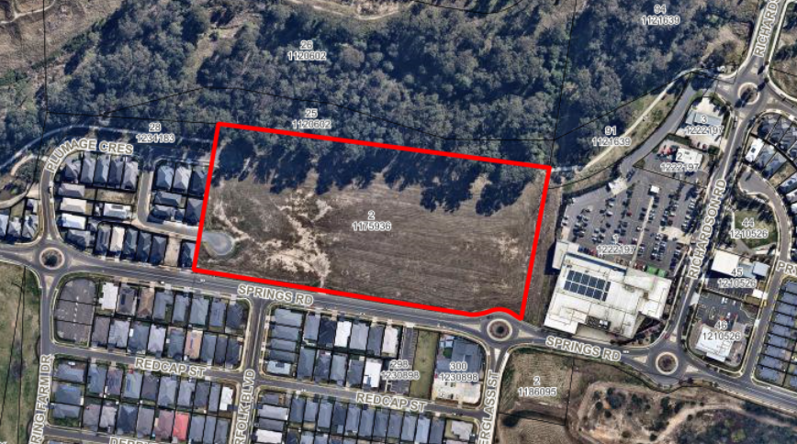
Image 1: Aerial photograph of the development site

Image 2: Site as viewed from Springs Road looking north west

Image 3: Site as viewed from Springs Road looking north east.

Image 4: Site as viewed from Oilseed Way looking east across the site towards the Spring Farm Town Centre.

Image 5: Site as viewed from the Woolworths Carpark looking west across the site
Image 6: To the north, adjoining bushland located along the entire northern property boundary
Image 7: To the immediate east of the development site, Spring Farm Town Centre, including Woolworths Supermarket.
Image 8: To the east, Endeavour Energy Transmission line and easement traversing the eastern boundary of the site and western boundary of the Spring Farm Town Centre.

Image 9: To the south, existing dwelling homes.
Image 10: To the south, opposite the site, the Bluebird Early Educational Childcare Centre at 134 Springs Road, Spring Farm.

